Connecting EDI Datasets to CNRA Portal

1. Set up an account by going to [https://data.cnra.ca.gov/user/login](https://gcc02.safelinks.protection.outlook.com/?url=https%3A%2F%2Fdata.cnra.ca.gov%2Fuser%2Flogin&data=02%7C01%7C%7C52fa6c2159c14ae6336108d80d962a7b%7Cb71d56524b834257afcd7fd177884564%7C0%7C0%7C637274285913519184&sdata=Gyo%2FQVHorciDi76CuiQowHR2U76W%2BvyAvxs5NHrj6hw%3D&reserved=0)
   1. Select, Create an Account, and fill in the appropriate information. For username, we recommend for consistency using the same username as your agency login

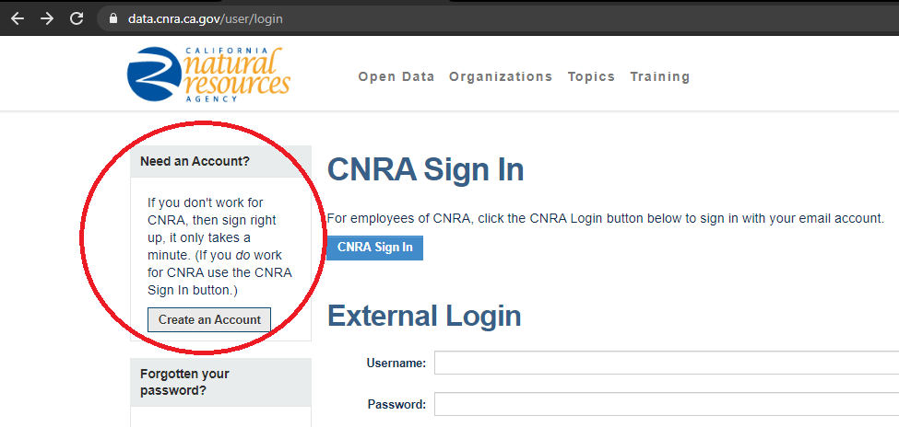

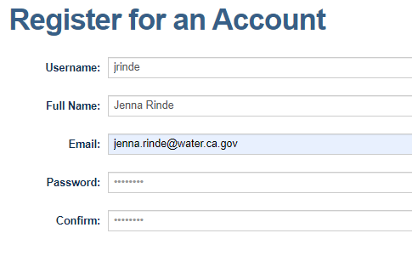

1. Have your PI or their supervisor email Kate and Dave for you to gain permissions.
   1. Email: ODP Support@CNRA <[odp.support@resources.ca.gov](mailto:odp.support@resources.ca.gov)>; Harris, David@DWR <[david.harris@water.ca.gov](mailto:david.harris@water.ca.gov)>
   2. ‘cc the appropriate email contacts for people you want to get permissions
   3. Example message:

Hi Kate and Dave,

I am the PI or manager for Example Study or Monitoring Program, a part of the Interagency Ecological Program. My team and I have published our data on EDI and would like to link our datasets from EDI to the CNRA. My staff have already set up accounts on CNRA, and their email addresses are listed below. I authorize permission for them to edit data on the CNRA portal. Can you please grant them permissions to add their datasets to the portal?

Users:   
 [Jenna.Rinde@water.ca.gov](mailto:Jenna.Rinde@water.ca.gov)  
 [Catarina.Pien@water.ca.gov](mailto:Catarina.Pien@water.ca.gov)

1. Once you receive an e-mail saying you have permissions, then log in at [https://data.cnra.ca.gov/user/login](https://gcc02.safelinks.protection.outlook.com/?url=https%3A%2F%2Fdata.cnra.ca.gov%2Fuser%2Flogin&data=02%7C01%7C%7C52fa6c2159c14ae6336108d80d962a7b%7Cb71d56524b834257afcd7fd177884564%7C0%7C0%7C637274285913519184&sdata=Gyo%2FQVHorciDi76CuiQowHR2U76W%2BvyAvxs5NHrj6hw%3D&reserved=0). Log in through the “CNRA Sign In” button on CNRA Sign In. Do not log in through External Login.

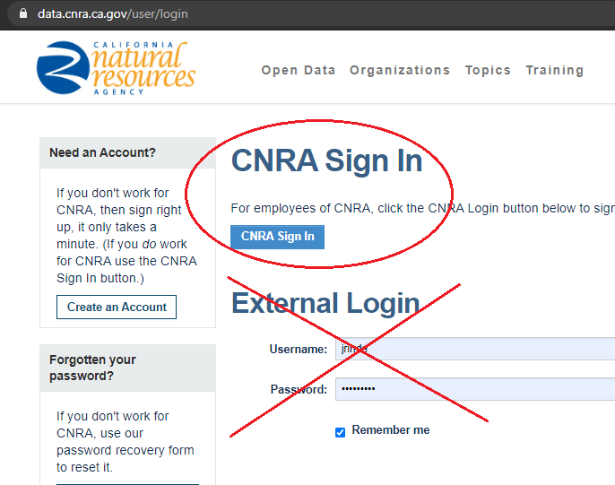

1. Click **Open Data** at the top of the page.

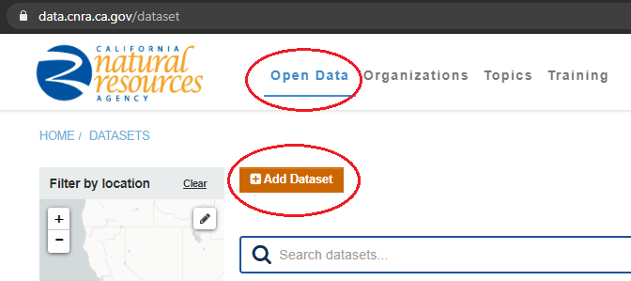

1. Fill in information for your dataset!
   1. Generally, fill in only required fields as we are trying to encourage users to go to the EDI page for data and information. Use <https://data.cnra.ca.gov/dataset/ybfmp-zooplankton> as template for what to fill in, and how to link to EDI (Homepage URL and under Data and Resources).

**Step by Step Directions**

* Title
  + Copy the same title as listed on EDI
* URL
  + This defines what you want the URL to be named on CNRA. Don’t copy your DOI citation here from EDI.
  + Example: iep-emp-do-study
* Description
  + Copy the abstract from EDI and post here
* Tags
  + If left blank your tags from EDI should automatically transfer over
* Organization
  + Select your agency
* Visibility
  + Change from Private to Public
* Publisher
  + Copy your citation from EDI
* Program
  + List your program name (optional)
* Homepage URL
  + Copy and paste your EDI link

[Scroll down through the optional items]

* Contact Name
* Contact Email

[Scroll down through the optional items]

* Define Bounding box
  + Under “Bounding Coordinate”
    - Copy the North, East, South, West Bounding coordinates used to the metadata template for EDI

[Scroll down through optional items]

* Public Access Level
  + Public
* License
  + Creative Commons Attribution
* Limitations
  + Copy text from your EDI dataset. At the top of your EDI data package page, click “View Full Metadata”
  + Scroll down
  + Select “Data Package Usage Rights” then copy the text below it into the Limitations section on CRNA

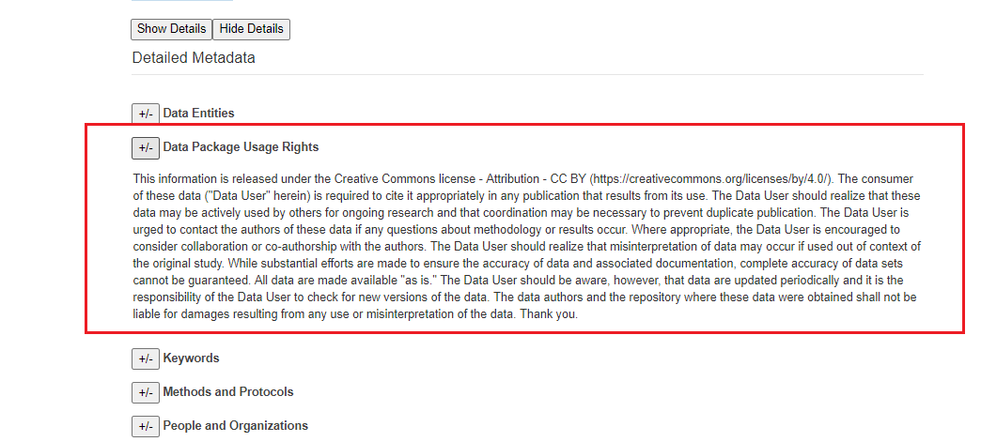

Scroll down to the bottom. On the bottom right in blue box, select “Next: Add Data”

* Click the “link” option at the top.
  + Under URL, copy your DOI URL from EDI
* Title
  + Use same title as listed on EDI
* Description
  + Use your EDI abstract
* At the bottom right, push the “Finish” blue button

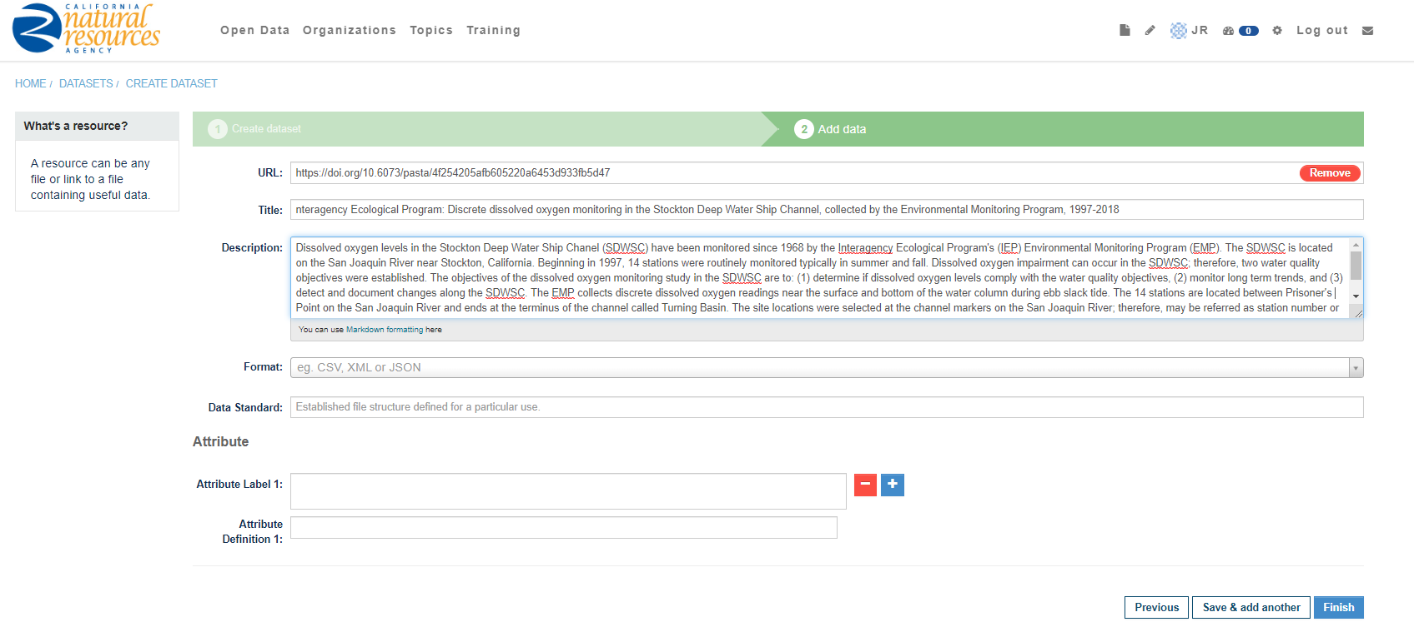

1. View your dataset!
2. If you need to edit after you have published, click on your icon with your initials on the toolbar, click your dataset, and click the “Manage” button on the top right under the toolbar. Click “Update Dataset” to finalize.
   1. To edit the page where your data links, click the “Resources” tab, click on the link, and edit. Click “Update Resource” to finalize.

